ENTERPRISE AI
KNOWLEDGE ORCHESTRATOR

Technical Documentation
Multi-Agent AI Orchestration Workflow
OpenAI Agents | RAG | MCP Integrations

Author | Alba
Role | AI & Cloud Engineering
Date | May 2026
Version | 1.0

TABLE OF CONTENTS
1. Project Overview 1
2. Project Objectives 1
3. System Architecture 1
3.1 Architecture Flow 1
4. Workflow Components 1
4.1 Classify Request 1
4.2 Web Research Agent 1
4.3 Local Knowledge Agent 1
4.4 Google Drive Retrieval Agent 1
4.5 General AI Assistant 1
4.6 State Management Layer 1
4.7 Summarization Layer 1
5. MCP Integration 1
5.1 Current MCP Integrations 1
6. RAG Implementation 1
6.1 RAG Components 1
7. Tech Stack 1
8. Current Limitations 1
9. Future Improvements 1
9.1 Short-Term 1
9.2 Long-Term 1
10. Appendix 1
10.1 Full Workflow Diagram 1
10.2 Document Version History 1

1. Project Overview
This project implements a multi-agent AI orchestration workflow using OpenAI Agents, Retrieval-Augmented Generation (RAG), MCP integrations, and conversational state management.
The system dynamically routes user requests to specialized AI agents capable of performing web research, local document retrieval, Google Drive knowledge retrieval, and general conversational reasoning. The workflow also includes response summarization and conversational continuity handling.

2. Project Objectives
- Build a modular multi-agent AI architecture
- Implement intelligent request routing via intent classification
- Integrate retrieval-based knowledge systems (RAG)
- Connect external MCP providers (Google Drive)
- Maintain conversational continuity through state management
- Create a scalable orchestration workflow
- Simulate enterprise AI assistant behaviors

3. System Architecture
The system follows a layered architecture where user requests flow through classification, routing, agent execution, state management, and summarization before producing the final response.

3.1 Architecture Flow
The high-level execution pipeline is as follows:
- User submits a request to the system
- Intent Classification Layer analyzes and categorizes the request
- Multi-Agent Routing dispatches the request to the appropriate specialized agent
- State Management Layer persists conversational context
- Summarization Layer formats and refines the final response
- Final response is delivered to the user

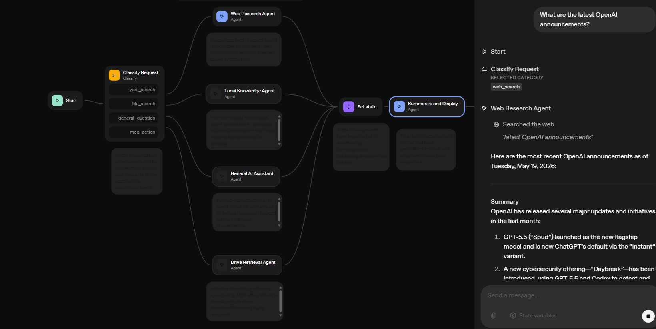

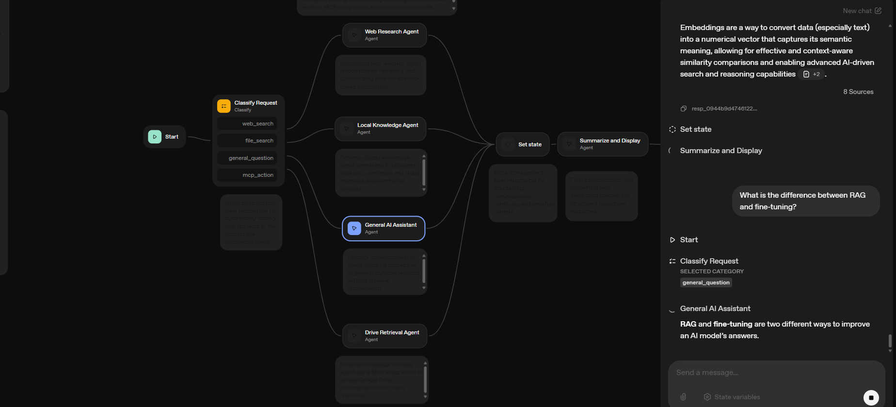
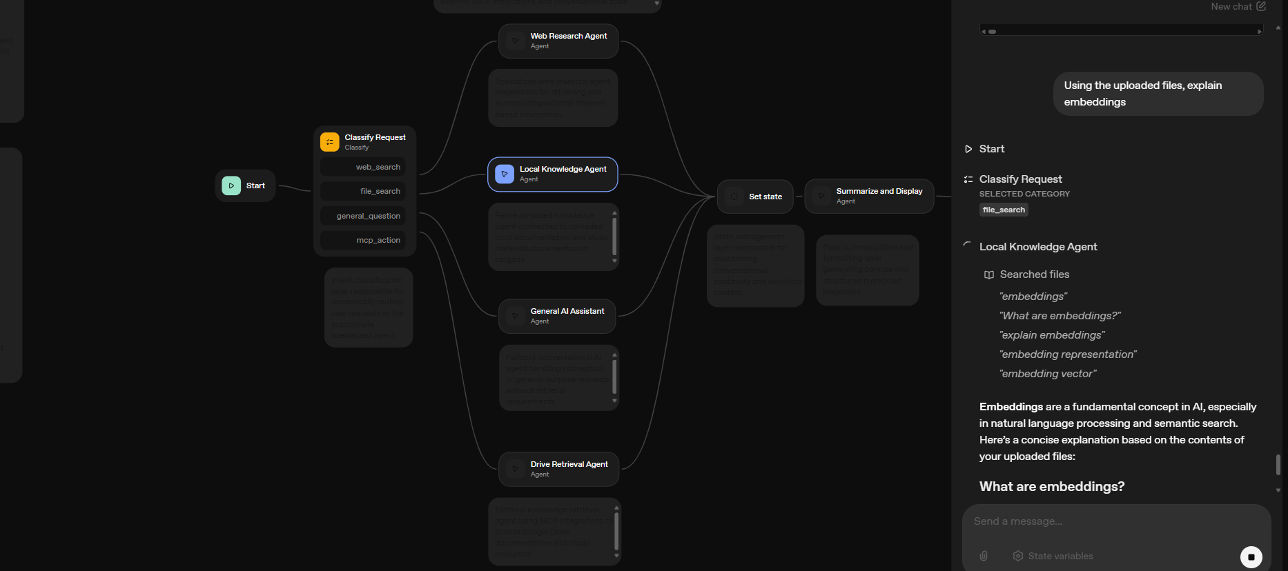

4. Workflow Components

4.1 Classify Request
The classification layer is the entry point of the workflow. It dynamically routes user requests based on intent detection, determining the most appropriate execution path for each incoming query.
Supported routing categories:
Category | Description
web_search | Routes to Web Research Agent for internet-based queries
file_search | Routes to Local Knowledge Agent for document retrieval
general_question | Routes to General AI Assistant for conversational queries
mcp_action | Routes to Drive Retrieval Agent via MCP integration
The classifier uses example-based intent classification to determine the most appropriate execution path.

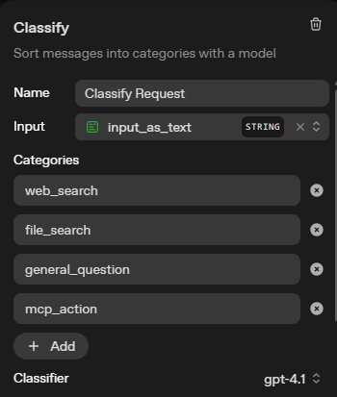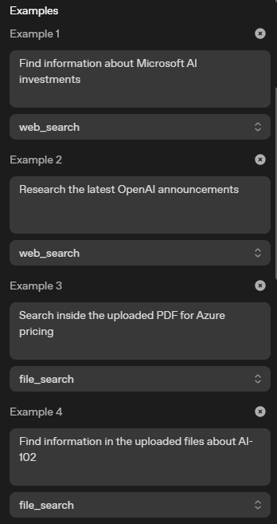

4.2 Web Research Agent
Specialized AI agent responsible for retrieving and analyzing internet-based information using integrated web search tools. This agent is activated when the classifier detects a web_search intent.
Capabilities:
- Online research and real-time information retrieval
- Summarization of external web content
- Technical information extraction from internet sources
- Current events and up-to-date data gathering

📷 SCREENSHOT PLACEHOLDER
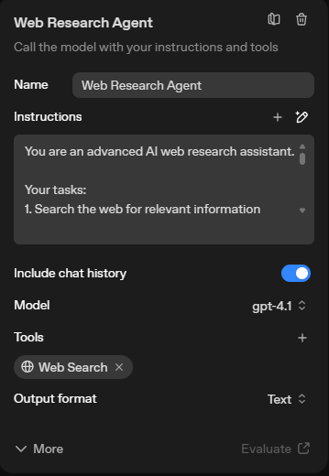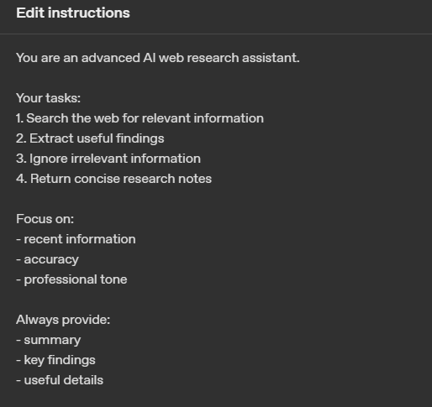

4.3 Local Knowledge Agent
Retrieval-based AI agent connected to uploaded local documentation and study material. This component implements Retrieval-Augmented Generation (RAG) workflows.
The agent operates by indexing uploaded documents, performing semantic retrieval against user queries, and injecting the retrieved contextual information into model prompts to generate grounded, accurate responses.

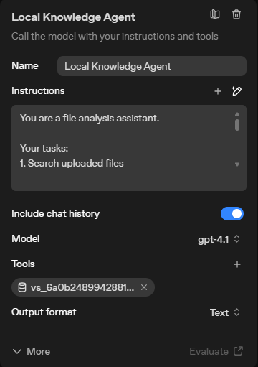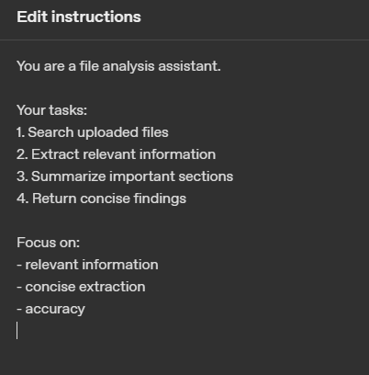

4.4 Google Drive Retrieval Agent
MCP-enabled external retrieval agent connected to Google Drive documentation. This agent retrieves and summarizes externally stored documents using Google Drive API integrations and MCP orchestration.
Capabilities:
- External document retrieval from Google Drive
- Study material analysis and summarization
- Technical document summarization
- Google Drive semantic search

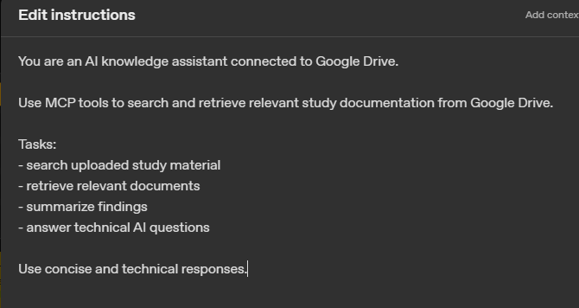
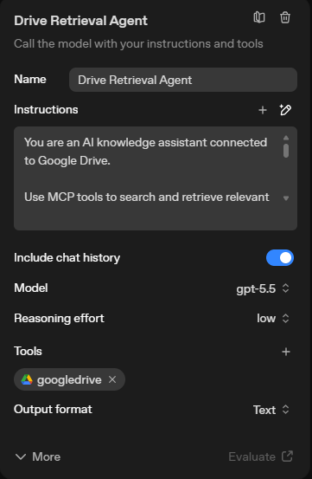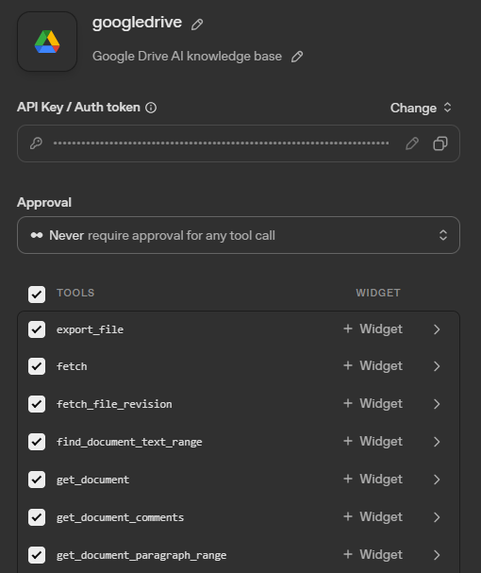

4.5 General AI Assistant
Fallback conversational AI agent responsible for answering conceptual or general-purpose requests without retrieval dependencies. This agent relies primarily on pretrained LLM knowledge and is activated when no specialized retrieval is needed.

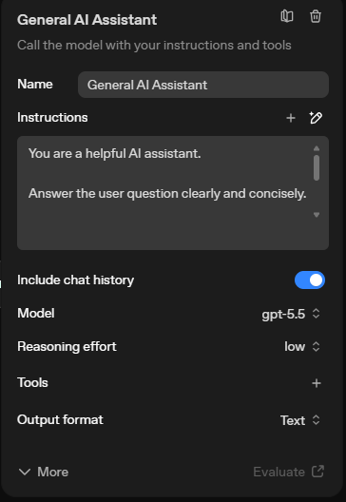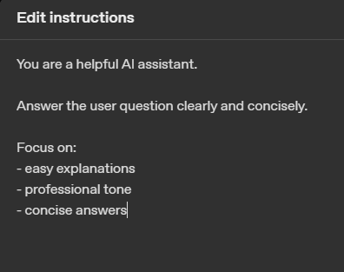

4.6 State Management Layer
The workflow includes conversational state handling using Set State nodes. This layer is responsible for maintaining context persistence across the conversation, enabling workflow continuity and sharing conversational context between agents.
Current functionality includes conversation context persistence, workflow continuity between sequential requests, and shared conversational context between the different specialized agents.

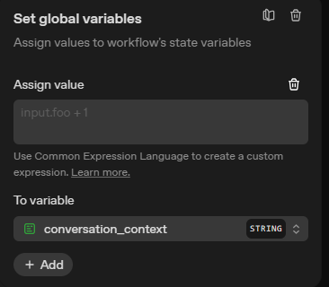

4.7 Summarization Layer
The final AI layer in the pipeline is responsible for processing agent outputs into polished, user-ready responses. It performs response cleanup, Markdown formatting, concise summarization, and structured response generation.
This layer ensures that regardless of which agent processes the request, the final output maintains a consistent format and quality standard.

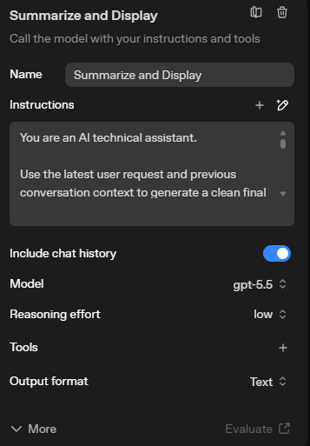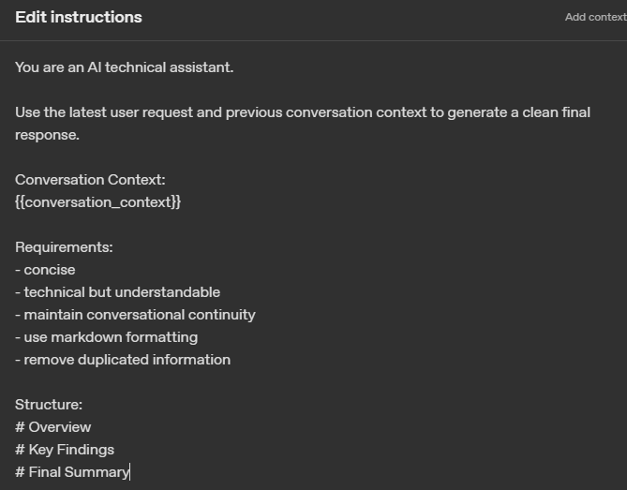

5. MCP Integration
The project integrates MCP (Model Context Protocol) connectors to extend agent capabilities with external systems. MCP enables the agents to interact with third-party services in a standardized way.

5.1 Current MCP Integrations
Integration | Authentication | Purpose
Google Drive | OAuth 2.0 / Google Cloud API credentials / Access token | External document retrieval and knowledge augmentation
The MCP integration enables enterprise-style AI interactions where the orchestrator can pull knowledge from external, cloud-hosted document repositories.

6. RAG Implementation
The project implements Retrieval-Augmented Generation (RAG) behavior using multiple retrieval sources. No fine-tuning is performed; the system dynamically retrieves relevant contextual information during inference time.

6.1 RAG Components
Component | Description
Local Files | Uploaded documentation indexed for semantic retrieval
Semantic Retrieval | Query-based document matching for contextual responses
Prompt Augmentation | Injection of retrieved context into model prompts
MCP External Retrieval | Google Drive document retrieval via MCP connectors

7. Tech Stack
Technology | Role
OpenAI Agents | Multi-agent orchestration framework
GPT-4.1 / GPT-4o | Base language models for agent reasoning
MCP | Model Context Protocol for external integrations
Google Drive API | External document access and retrieval
OAuth 2.0 | Authentication for external service connections
RAG | Retrieval-Augmented Generation for contextual responses
Workflow Orchestration | Pipeline management and agent coordination
State Management | Conversational context persistence

8. Current Limitations
- No persistent long-term memory across sessions
- Limited autonomous tool reasoning capabilities
- Retrieval quality depends on query phrasing and document indexing
- No frontend/UI layer implemented yet (backend workflow only)
- MCP integrations currently limited to Google Drive

9. Future Improvements

9.1 Short-Term
- Persistent memory system for cross-session continuity
- User preference management and personalization
- Advanced orchestration reasoning with autonomous tool selection
- Frontend chat interface for end-user interaction

9.2 Long-Term
- Additional MCP integrations (GitHub, Jira, Slack)
- Multi-session persistence and long-term contextual memory
- Advanced autonomous tool selection and chaining
- Enterprise deployment readiness and scalability enhancements

10. Appendix

10.1 Full Workflow Diagram
The following screenshot shows the complete orchestration workflow as implemented in the OpenAI Agents platform:

📷 SCREENSHOT PLACEHOLDER
Insert here: Full-screen capture of the complete workflow (the same image provided with this documentation request, showing all nodes from Start to End)

10.2 Document Version History
Version | Date | Author | Changes
1.0 | May 2026 | Alba | Initial documentation release

